
Dear Student Applicant,
Thank you for your interest in the Missouri State University Upward Bound Program. Before completing the Upward Bound application, it is important to read and understand what being an Upward Bound participant is all about. The purpose of Upward Bound is to assist students in the development of academic skills and motivation necessary to succeed both in high school and beyond. Through academic tutoring and instruction, the Upward Bound Program assists participants with high school study and encourages them to pursue a college education. On selected Saturdays, students, tutors, and staff meet for sessions called “Destined for College” meetings.
Upward Bound is a federally funded TRIO program that works with 54 students from three target high schools in the city of Springfield. Participants are students who are interested in sharpening their academic skills and pursuing education after high school graduation. The Missouri State Upward Bound program serves the following Springfield high schools: Central, Hillcrest, and Parkview.
Upward Bound activities must be taken seriously by each participant. Students who are admitted agree to take part in both the academic year and six-week summer program. These important components have the following objectives:
- To increase the academic performance of program participants.
- To assist participants in developing a motivation to succeed in high school and attend college.
- To provide informative and enriching educational opportunities for all participants.
- To encourage participation in cultural/educational experiences beyond those available at their high schools.
- To provide tutoring, career exploration, and college advising to participants.
- To provide assistance in securing admission to a postsecondary institution and guidance in acquiring financial aid.

We are grateful for the support of the university, the U.S. Department of Education, the area public school system, the community, and our educational partners. We are confident that we can and will continue to help address the academic needs and challenges of our students.

Sincerely,
TRIO Upward Bound Staff

Missouri State University
901 S. National Avenue
Springfield, MO 65897
Nicholas Horne, Director
Main Office, 417-836-6220

About the Upward Bound Program
The Missouri State University TRIO Upward Bound Program is a pre-college program administered by the U.S. Department of Education and is designed to prepare and motivate high school students for postsecondary education. The program serves 54 students in 9th through 12th grade at Central, Hillcrest, and Parkview high schools. Students who are accepted into the program remain in the program until graduation from high school or until the student is released from the program, either voluntary or involuntary.

Priority is given to applicants whose economic status or taxable income meets the Federal TRIO Income Guidelines (see Part II: Eligibility Verification) and who demonstrate academic need. Although grades are important, they are not necessarily used in determining whether or not a student is eligible for Upward Bound; throughout the program, students must demonstrate academic potential.

The following is a brief outline of the services that a student will receive through Upward Bound:

Academic Year Component (September-May):
- Tutoring sessions at your high school (Frequency depends on GPA).
- Meeting with site coordinator once per month at your high school.
- After School Meetings twice per month at your high school.
- Various activities in Springfield and at Missouri State University.
- Saturday Destined for College Meeting once per month at Missouri State University.
  - Includes career, college, cultural and academic activities.

Summer Component (June-July):
- High school-level instruction (Monday-Thursday for six weeks) at Missouri State.
  - Classes include Math, Science, Languages, English, Social Sciences, and Electives.
  - Lunch provided.
  - Evening activities.
  - Fun Fridays-includes trips, college tours, seminars, sports, and other activities.
- Possible out-of-state Cultural/Educational Trip.

Year-Round Services
- Personal, academic and career counseling/advising.
- Stipends-monetary rewards given to students for participation.
  - Up to $100 per semester during the academic year component.
  - Up to $60 per month during the summer component.
- ACT/SAT Preparation.
- College Tours.
- Field Trips.
- Financial Aid and Scholarship Education.

All expenses for participating in the Upward Bound programs, activities and events are paid for by the Program.
For more information, please call (417) 836-6220.
Checklist
This check list is to assist you in completing the
Upward Bound application

Carefully complete the entire application.

Forms to be completed by parent/guardian and student:

- Student Information
- Eligibility Verification with student and parent/guardian signatures
- Release of Student Information with student and parent/guardian signatures

Forms to be completed cooperatively with Target High School: and turned back into Highschool counselor or picked up by Upward Bound Staff member.

Please Direct Questions To:
upwardbound@missouristate.edu 417-836-6220

AND Notify when application is complete!

Good luck! Hope to follow up with you soon!


PART I: STUDENT INFORMATION

Name
(Last) (First) (Middle)

Address
Street Address or PO Box City State Zip Code

School Email Student Phone

High School Grade

Date of Birth Place of Birth

Social Security # Gender Male Female
(If you do not have a Social Security number, please check here: ____)

GPA

Ethnicity (This information is optional and will be used for reporting purposes only.)  African American  Hispanic/Latino  Native American/Native Alaskan  Asian  Native Hawaiian/Pacific Islander  Caucasian  Middle Eastern  Multiracial (please specify)  Other (please specify) | US Citizen?  Yes No  Resident Alien?  Yes No  Alien Registration  #A

Why do you want to join the Missouri State University Upward Bound Program?

Low grade point average
Low achievement test scores
Low Educational Aspirations
Low GPA and Low Educational Aspirations
Low GPA and Low achievement test scores
Low achievement test scores and low educational Aspirations
Lack of opportunity support and/or guidance to take challenging college preparation courses
Lack of career goals and or/ need for accurate information on careers
Limited English proficiency
Lack of confidence, self-esteem, and/or social skills
Predominantly low-income community
Rural isolation
Interest in careers in math or science
Other
Unknown
Diagnosed Learning disability

PART II: Eligibility Verification
The information reported on this form is only used to determine a prospective participant’s eligibility under Upward Bound federal guidelines and will remain confidential.

Name ____________________________ S.S.N. ________________________

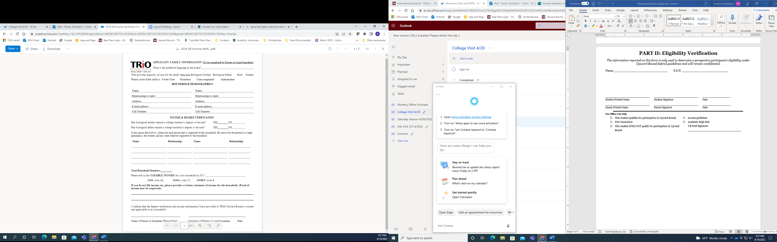
Please Tell us the TAXABLE INCOME for your household in 2023: ___________________ (Line 15 on 1040)

If you did not file income tax, please provide a written statement of income for the household. (Proof of income may be requested.

I confirm that the degree verification and income information I have provided to TRIO Upward Bound is current and applicable to my household.

______________________________ ______________________________ ___________________
^{Student Printed Name} ^{Student Signature} ^{Date}
______________________________ ______________________________ ___________________
^{Parent Printed Name} ^{Parent Signature} ^{Date}

For Office Use Only
- This student qualifies for participation in Upward Bound. | - Income guidelines
- First Generation | - Academic High Risk
- This student DOES NOT qualify for participation in Upward Bound

UB Staff Signature
________________________________________________

PART III: INFORMATION RELEASE FORM

Student’s Name High School

I hereby give the Missouri State University TRIO Upward Bound Program permission to receive copies of educational records and other materials necessary for participation in the Program. Further, permission is granted to request academic and financial aid information and records from any and all post-secondary institutions in order to track college progress. I understand all of my records will be kept in confidence and in accordance with the Privacy Act of 1974.

You have our consent to release grades, test scores, and any other academic records to the Missouri State University TRIO Upward Bound Program.

(Student’s Signature) (Parent’s Signature) (Date)

As a parent/guardian of this student, I hereby consent to the use of photographs/videotape taken during the course of participation in the Upward Bound program for publicity, promotional and/or educational purposes (including publications, presentation or broadcast via newspaper, internet or other media sources). I do this with full knowledge and consent and waive all claims for compensation for use, or for damages.

_____ Yes, I give consent for the Missouri State University TRIO Upward Bound Program to photograph my child for program purposes and/or at program events.

_____ No, I do not authorize the Missouri State University TRIO Upward Bound Program to photograph my child for any event.

______________________________ ______________________________ ___________________
^{Student Printed Name} ^{Student Signature} ^{Date}
______________________________ ______________________________ ___________________
^{Parent Printed Name} ^{Parent Signature} ^{Date}

For Office Use Only

Students Grade Point Average: ______ on ______ scale. Student’s Class Rank: ______ out of ______
Test Scores: Circle the level that applies
Math: Below Basic Basic Proficient Advanced MAP EOC Other: ___________
Reading/ELA: Below Basic Basic Proficient Advanced MAP EOC Other: ___________

Has this student completed or enrolled in Algebra I by their Sophomore Year? YES NO
Has this student completed or enrolled in a unit of Foreign Language? YES NO

UB Staff Signature: _________________________________

- Academic High Risk

